OWNML MACHINE LEARNING CANVAS

Designed for: Designed by: Date: Iteration: .
  PREDICTION TASK  What is the type of task?  Which entity are predictions made on?  What are the possible outcomes to predict?  When are outcomes observed?  Type of task: Multi-class classification (Low / Medium / High churn-risk prediction)  Entity: Each entity represents one telecom customer  Possible outcomes: Customer churn risk: Low, Medium, or High  Churn is recorded at the end of the monthly billing cycle |   DECISIONS  How are predictions turned into actionable recommendations or decisions for the end-user? (Mention parameters of the process / application for this.)  Predictions are converted into actionable decisions by mapping the churn probability to a risk category (Low, Medium, High).  Based on the assigned risk level, the system generates targeted recommendations such as offering discounts, upgrading plans, following up with the customer, or routing high-risk customers to the retention team.  These results are displayed in the Streamlit demo as the predicted probability, the risk category, and the corresponding recommended action. |   VALUE PROPOSITION  Who is the end beneficiary, and what specific pain points are addressed?  How will the ML solution integrate with their workflow, and through which user interfaces?  End Beneficiaries: Retention team, Customer service agents, Marketing team  Pain Points Addressed: Telecom companies lose significant revenue when customers churn, and traditional methods detect churn too late.  The ML model helps by:  • Identifying high-risk customers proactively  • Reducing revenue loss  • Lowering the cost of acquiring new customers  • Focusing retention efforts on the right customers instead of wasting resources  Workflow Integration:  The ML model integrates into the retention workflow through a simple Streamlit web application.  Agents input customer attributes, and the system instantly returns:  • Churn probability  • Risk level  • Recommended retention actions  User Interface:  A clean web-based dashboard where the agent can quickly review predictions and take immediate action. |   DATA COLLECTION  How is the initial set of entities and outcomes sourced (e.g., database extracts, API pulls, manual labeling)?  What strategies are in place to update data continuously while controlling cost and maintaining freshness?  The initial dataset was sourced from the Kaggle “Telco Customer Churn” dataset for early prototyping.  To improve model quality and obtain more realistic customer behavior patterns, the final model was trained using a telecom churn dataset hosted on Hugging Face (aai510-group).  In a real telecom company, customer profiles and churn outcomes would be sourced from internal systems such as CRM databases, billing platforms, and service-usage logs.  Data would typically be refreshed monthly as billing cycles close and churn outcomes become available. |   DATA SOURCES  Where can we get data on entities and observed outcomes? (Mention internal and external database tables or API methods.)  The dataset is the “Telco Customer Churn” dataset from Hugging Face.  Link: aai510-group1/telco-customer-churn · Datasets at Hugging Face
  IMPACT SIMULATION  What is the cost/gain values for (in)correct decisions?  Which data is used to simulate pre-deployment impact?  What are the criteria for deployment?  Are there fairness constraints?  To estimate business impact before deployment, a profit-based simulation is performed using the model’s predicted churn probabilities and risk buckets (Low, Medium, High).  Cost/Gain Values:  - True Positive (correctly identifying a high-risk customer): revenue saved from retention (e.g., $200).  - False Positive (incorrectly targeting a low-risk customer): cost of unnecessary retention incentives (e.g., $20).  - False Negative (missing a high-risk customer): full revenue loss from churn (e.g., $200).  - True Negative: no cost.  Data Used:  Historical churn-labeled data from the HuggingFace telecom dataset is used to simulate outcomes under different threshold settings.  Deployment Criteria:  The threshold is selected based on the maximum expected profit from the Profit Curve (e.g., best threshold ≈ 0.74), balancing savings from correctly retained customers against marketing costs.  Fairness Constraints:  Basic fairness checks ensure that risk predictions do not disproportionately target or exclude specific customer groups (e.g., senior customers or low-tenure customers). Additional fairness constraints can be added prior to deployment if required. |   MAKING PREDICTIONS  Are predictions made in batch or in real time?  How frequently?  How much time is available for this (including featurization and decisions)?  Which computational resources are used?  Predictions are generated in batch mode, not real time. In a practical telecom workflow, the model would run once per billing cycle or daily depending on operational needs.  Featurization is lightweight because all transformations (Tenure Bucket, ratios, one-hot encoding, imputations) are applied automatically through the same preprocessing pipeline used during training. Each prediction requires only a few milliseconds on a CPU.  The system runs efficiently on standard cloud compute (1–2 vCPUs) and does not require GPUs. After features are processed, the XGBoost model outputs:  - Churn probability  - Risk bucket (Low / Medium / High)  - Recommended retention action  This supports scalable batch processing across the entire customer base. |  |   BUILDING MODELS  How many models are needed in production?  When should they be updated?  How much time is available for this (including featurization and analysis)?  Which computation resources are used?  Only one production model is required: an XGBoost classifier trained to predict churn probability and assign customers to Low, Medium, or High risk.  The model should be retrained periodically, typically monthly, when new billing-cycle data becomes available. Retraining includes re-running the same preprocessing steps (Tenure Bucket, ratio features, one-hot encoding, median/ “Unknown” imputations).  Training time is low because XGBoost is efficient; the full training pipeline runs in under a few minutes on a standard CPU environment. No GPU is needed.  The production model uses basic compute (1–2 vCPUs) and can be deployed as a lightweight batch scoring job or integrated into a Streamlit-style dashboard for internal teams.  This setup ensures fast updates, easy maintenance, and consistent alignment with the training schema. |   FEATURES  What representations are used for entities at prediction time?  What aggregations or transformations are applied to raw data sources?  At prediction time, each customer is represented using a mix of raw and engineered features. These include:  Demographic: age, gender, senior citizen status, partner, dependents  Service-related: internet type, phone service, contract type, security/backup options, streaming services  Billing & usage: monthly charges, total charges, long-distance charges, number of referrals, tenure  The final model also uses light feature engineering such as tenure buckets, charge ratios, and standardized categorical values.  Categorical features are one-hot encoded, numerical values are median-imputed when needed, and the resulting feature vector is passed to the XGBoost model to generate churn probability and assign a Low / Medium / High risk level.
 | MONITORING  Which metrics and KPIs are used to track the ML solution’s impact once deployed, both for end-users and for the business?  How often should they be reviewed? | After deployment, the model is monitored using both prediction quality metrics and business KPIs.  Model Performance Metrics  • AUC and accuracy trends  • Precision/recall for each risk bucket (Low, Medium, High)  • Distribution of predicted risk levels over time  Business KPIs  • Reduction in churn rate among targeted customers  • Net revenue impact measured through the retention simulator  • Cost of retention incentives vs. revenue saved  • Number of customers successfully moved from Medium → Low risk after interventions  Monitoring is performed monthly, aligned with the billing cycle, and the model is retrained if performance or business impact declines. | 

 | Version 1.2. Created by Louis Dorard, Ph.D. Licensed under a Creative Commons Attribution-ShareAlike 4.0 International License.  Please keep this mention and the link to ownml.co when sharing. | OWNML.CO

[FREE] ONLINE COURSE

Introduction to the Machine Learning Canvas
Get started with the MLC in this short course taught by its author.

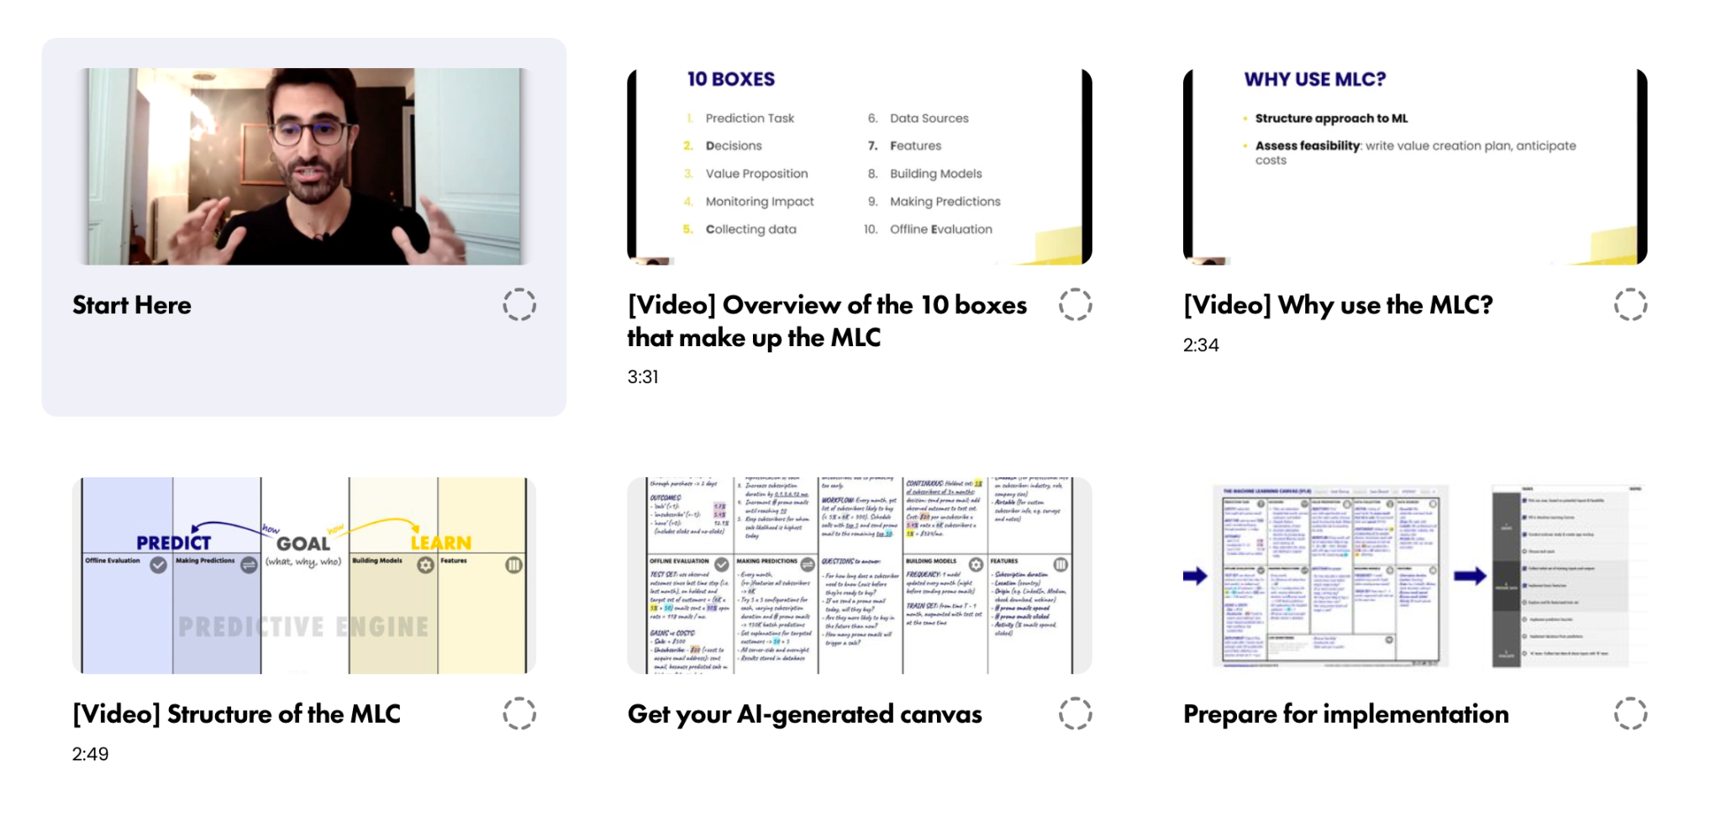

Start now at ownml.co/intro

